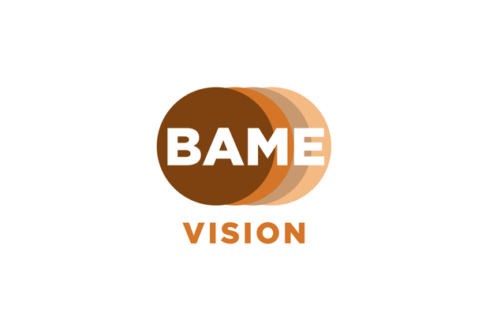
Logo Description: 4 solid circles interlinked, colours left to right, Brown, Tan, Coffee and Beige. The word BAME written in white within and Vision written underneath in tan.

BAME Vision Charter

This charter document is a pledge from BAME Vision to provide additional support if required when a charity, local society or community group agrees to make a difference in reaching and engaging with BAME communities. The supporting documents: our Toolkit and Resources documents, provide a wealth of tips and information to support in the first instance. We have been challenged with this ‘hard to reach’ predicament for decades and BAME Vision wish to address this inequality. BAME Vision is here to work with you and support you in making this difference to ensure that no one is left without adequate help, support, advice or information, in a way that is most convenient to them.

People from BAME Communities are not and should not be categorised in one box, group or be seen as a same as each other. People from different ethnic backgrounds have different experiences and outcomes and accessing healthcare – this needs to be considered in drawing up a pledge to reach out in your community.

What we would like your organisations to do differently as a result of this workshop in the next 3 - 6 months.

- Make an action plan, research what local communities are in your area. Reports such as the Joint Strategic Needs Assessment (JSNA) produced by local authorities or other data tools that show the percentage of the population from ethnic minority groups can help.

- Produce an engagement plan which could raise awareness amongst your employees of sight loss affecting the communities in your area.

- Reach out to local community organisations which are represented by BAME communities. Good examples include Mosques, Gurdwara, Temples and other religious organisations.

- Research common religious events or festivals that are most celebrated in your community, (you can visit the BAME Vision website for calendar of events) and see which ones you can engage with most effectively. You can take a look at the BAME Vision Toolkit for tips.

Please email info@bamevision.org to find out more and to access the Toolkit and Resources document.

Produced by BAME Vision

Email: info@bamevision.org
Website: www.bamevision.org
Twitter: www.twitter.com/BAMEVision
LinkedIn: www.linkedin.com/company/BAMEVision
Facebook: www.facebook.com/BAMEVision

